Performance Assessment
Kayla Sailer

Standard: 12.2.2 Perform in an ensemble.

I would approach this with two different assessments:
- Capability of playing their part alone for concert repertoire. (I will have 2-3 days set aside sometime before the concert for listening to students one-on-one in my office to assess their ability to accurately play their piece (see rubric 1 below).)
To do this, I will pick at least one section from each piece for the student to play. The student will not know which sections I am going to pick before they enter my office because it should be material they have been working on both in class and outside of class if need be so, if they have done that, it should be easy and it will be clear to me if they have not been doing the necessary work to contribute to the ensemble as a whole.

- Their contribution to the whole ensemble during the performance. (Do they show up on time for the concert? Do they act respectfully both while they are and are not playing? Are they dressed appropriately? etc. (see rubric 2 below).)
This part of the assessment is best explained by the rubric. It will depend solely on the student’s behavior and clothing choices before and during the concert. They will receive 50 points just for showing up and playing their part which will be a very large portion of their grade.

Rubric 1:
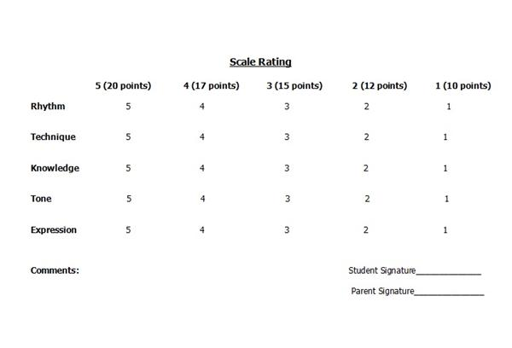
Rubric 2:
(5- The student showed up very well prepared and contributed to the ensemble;
4- The student showed up mostly prepared and contributed to the ensemble;
3- The student was somewhat prepared and/or somewhat contributed to the ensemble;
2- The student was not very prepared and/or did not contribute very much to the ensemble;
- The student was not prepared at all and/or did not contribute to the ensemble;
- The student did not show up for the performance.)
- Did the student show up at requested time?
- Was the student dressed appropriately?
  - Correct Color?
  - Not too revealing?
- Did the student look engaged?
- Did the student act respectfully during the concert?
  - No picking on/talking to neighbors?
  - Smiled at audience before & after final bow?
- Followed instructions.
  - Sat in correct spot.
  - Helped set up/tear down.
  - Any additional instructions:
- Student showed up & played for concert (50 points)

